[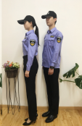](http://www.njgl.gov.cn/picture/0/530e53f5f4a14cb4be4506edb6133b84.png)   [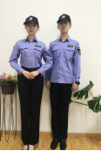](http://www.njgl.gov.cn/picture/0/95f020e08377400e97300d575eba24c9.png)       [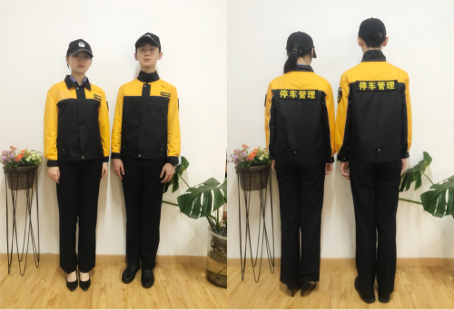](http://www.njgl.gov.cn/picture/0/6de8f7f8259942beab02f0e9bd341cf1.png)

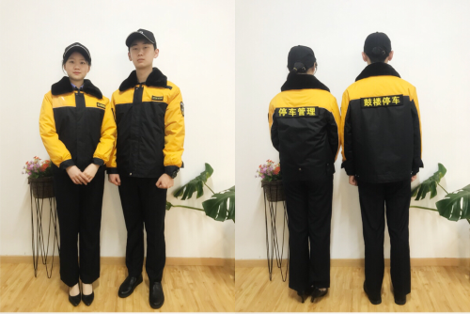            [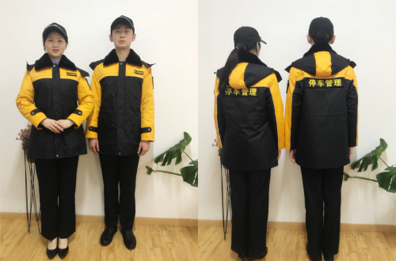](http://www.njgl.gov.cn/picture/0/27bf2835b9574635927d8b65fd5cbbf7.png)     [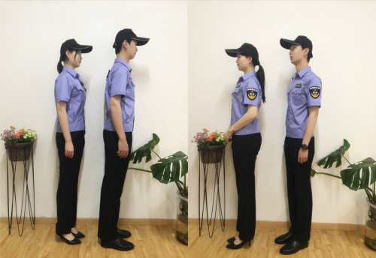](http://www.njgl.gov.cn/picture/0/f67910019dac407ba5d408db36054cb2.png)            [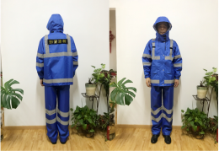](http://www.njgl.gov.cn/picture/0/5d497fb73cf34cbeb2258811369d43a4.png)

[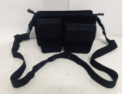](http://www.njgl.gov.cn/picture/0/26d02fb58e7143508ef1a381531eedcf.png)